sudo apt install gdb

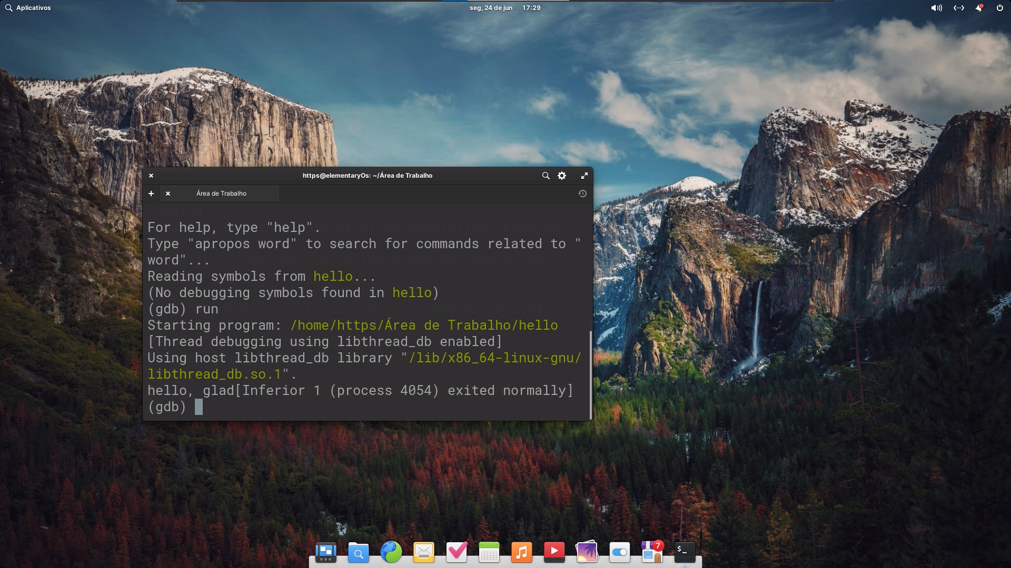*gdb*

*sudo apt install valgrind*

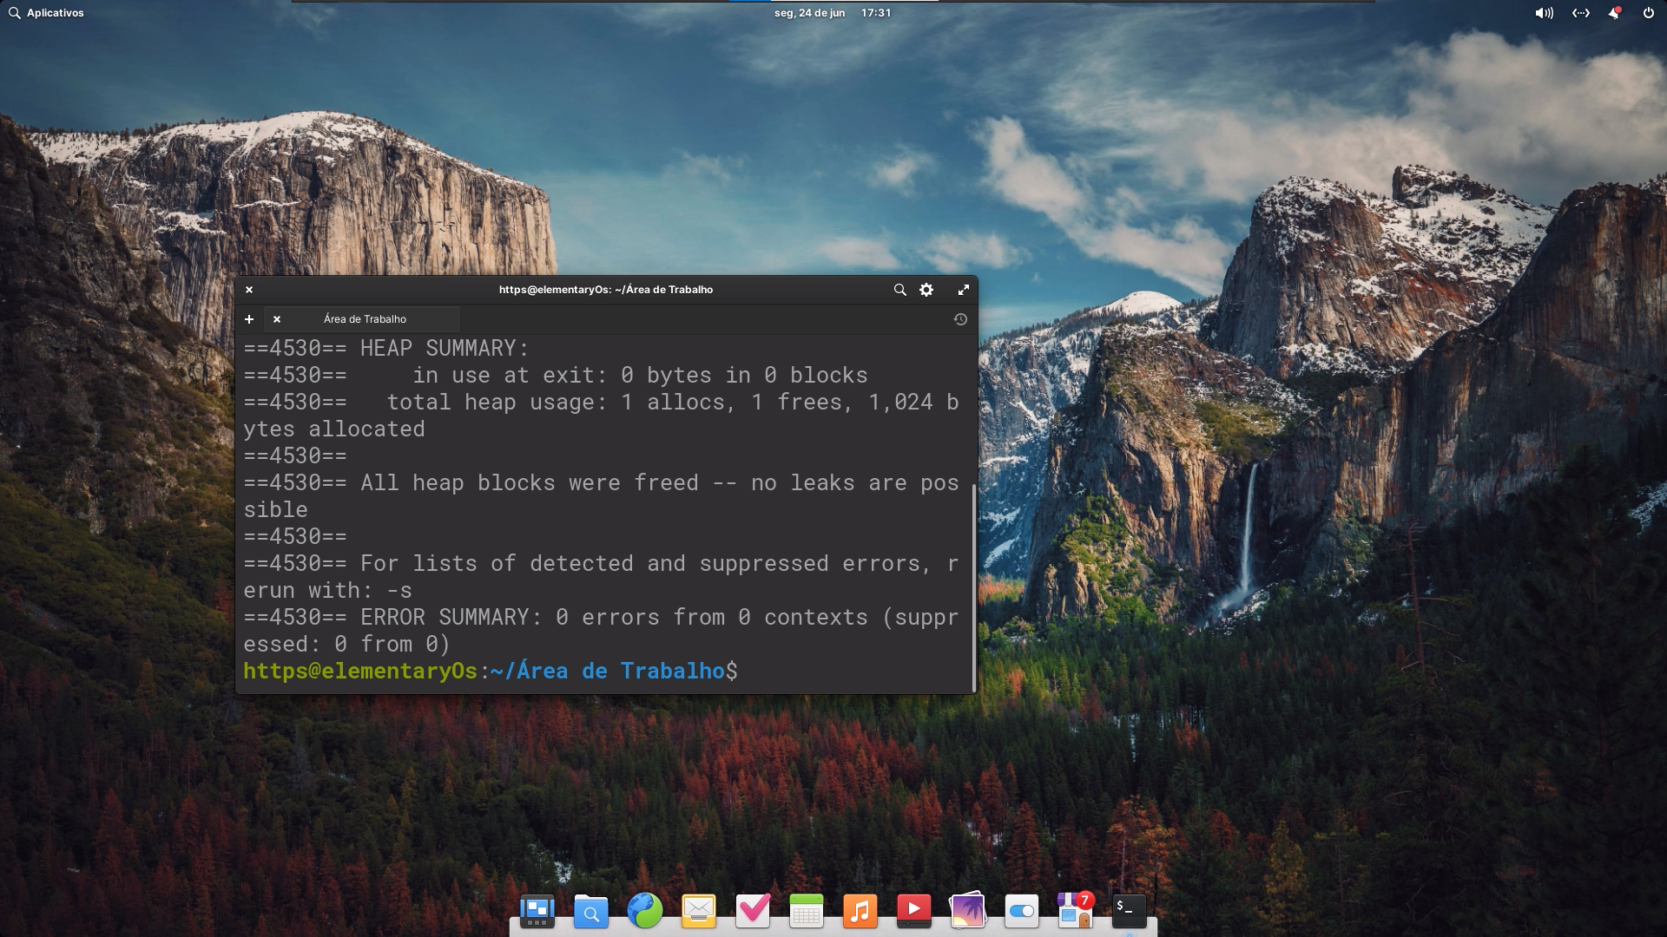*valgrind*

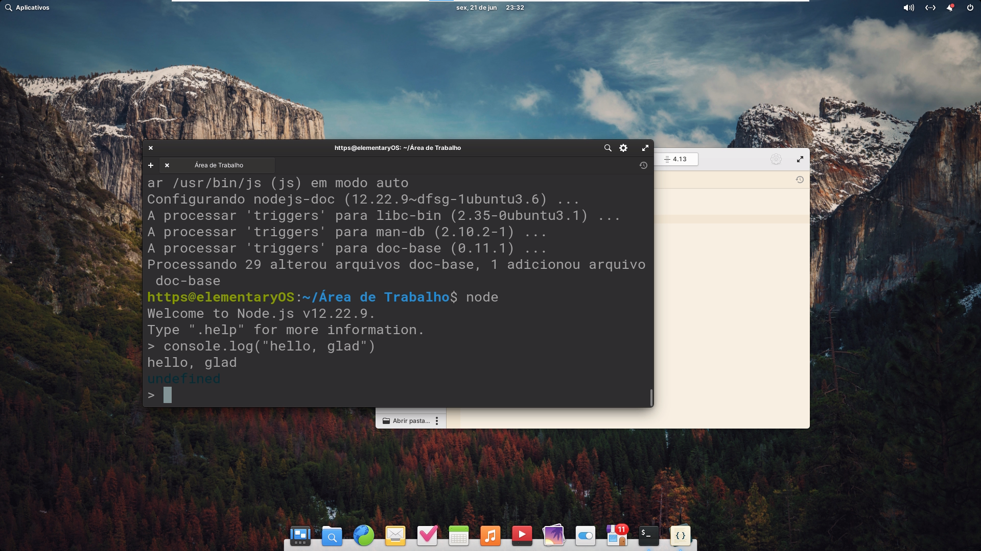*node*

Método de interação com o sistema (texto, GUI) contendo imagens

Interface gráfica de usuário ou terminal.

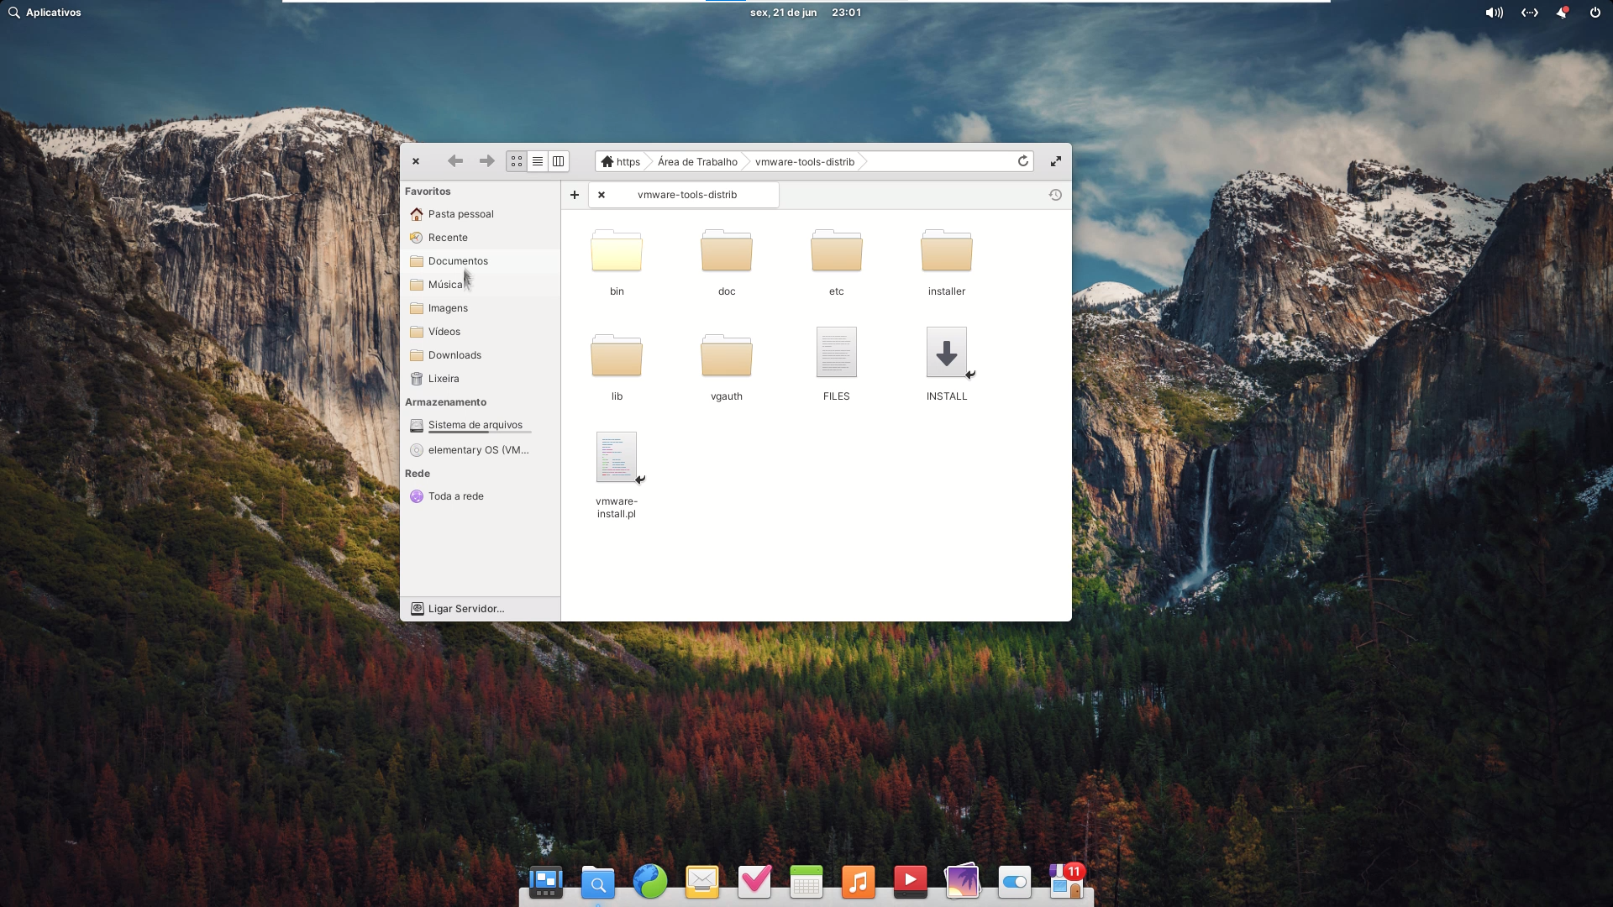*interface gráfica*

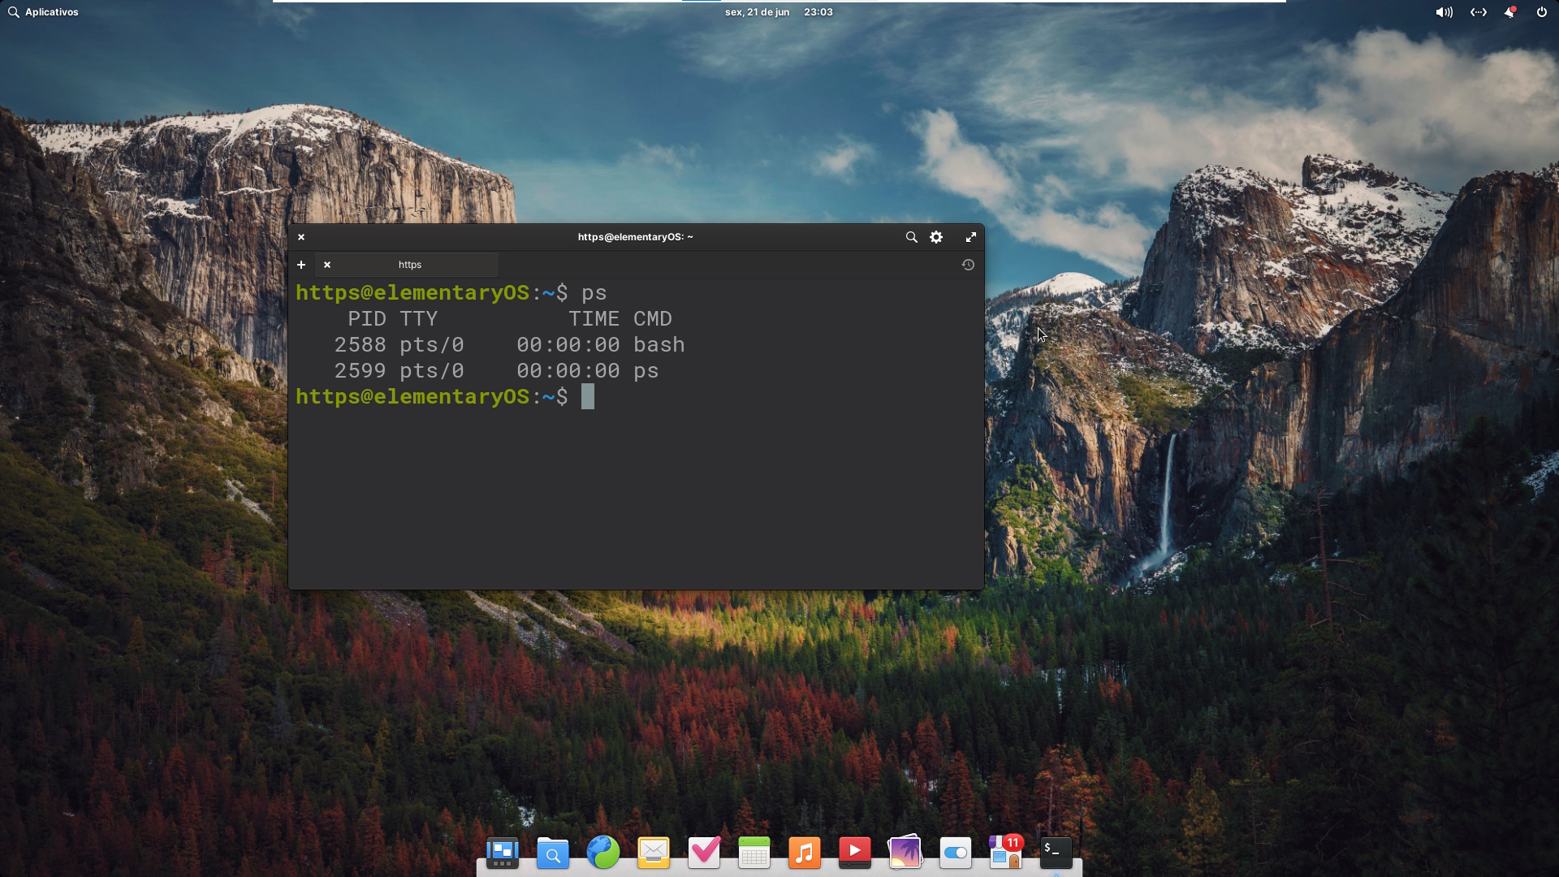*terminal*

Aplicações nativas de destaque do sistema operacional, contendo imagens

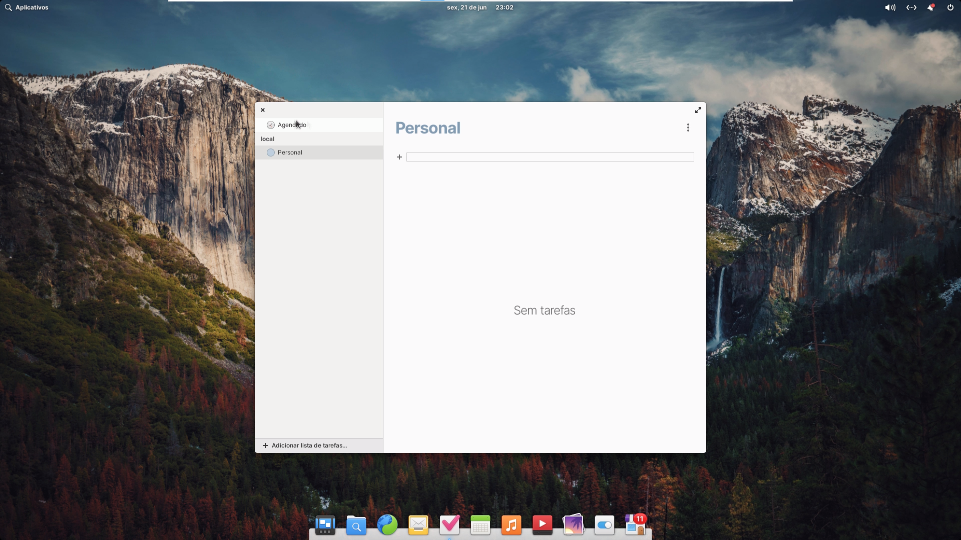*todo list*

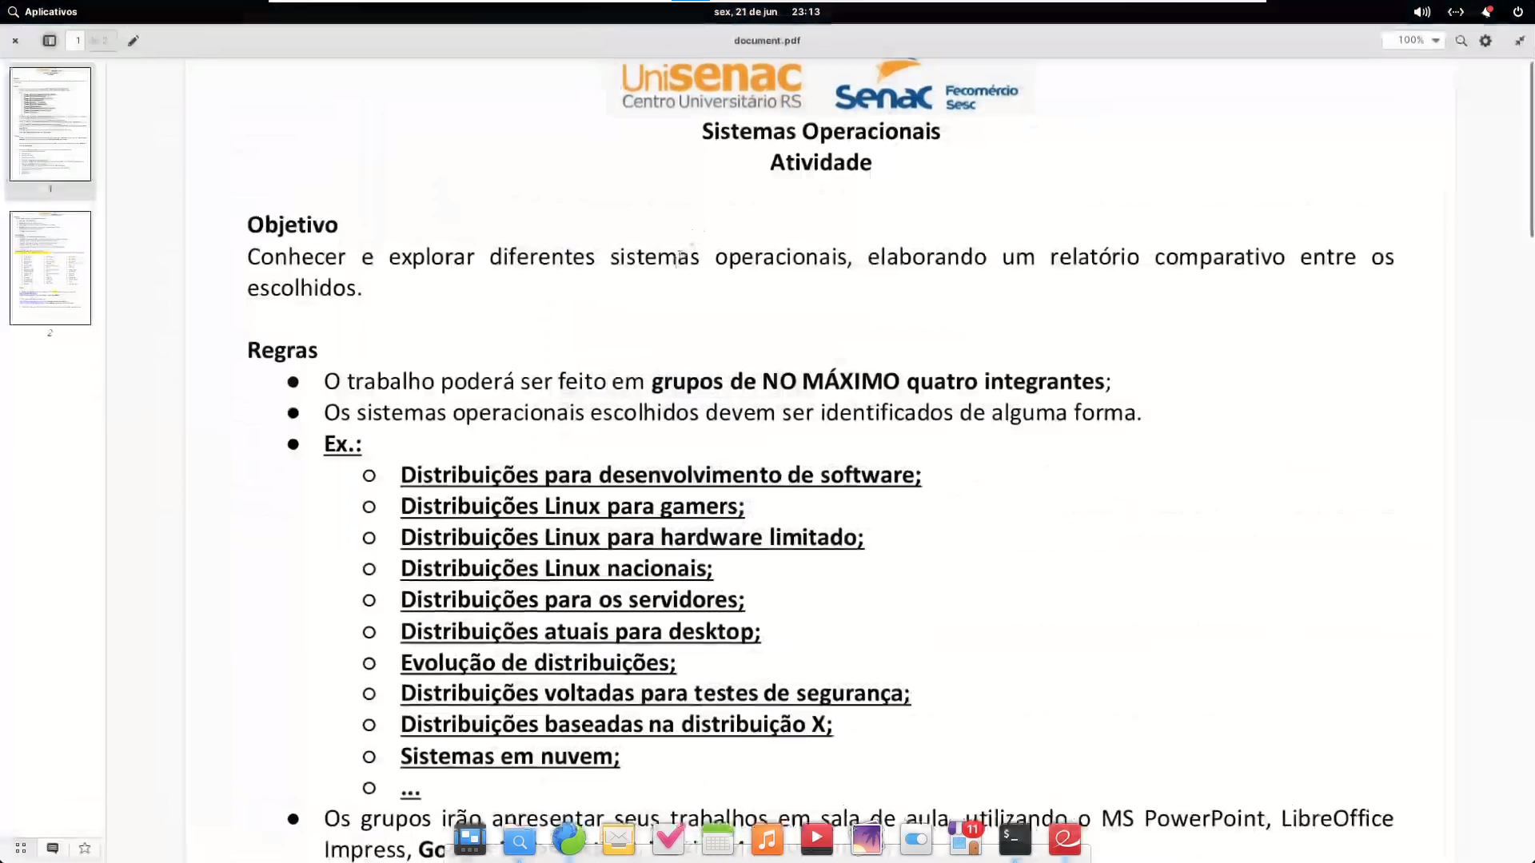*leitor de pdf*

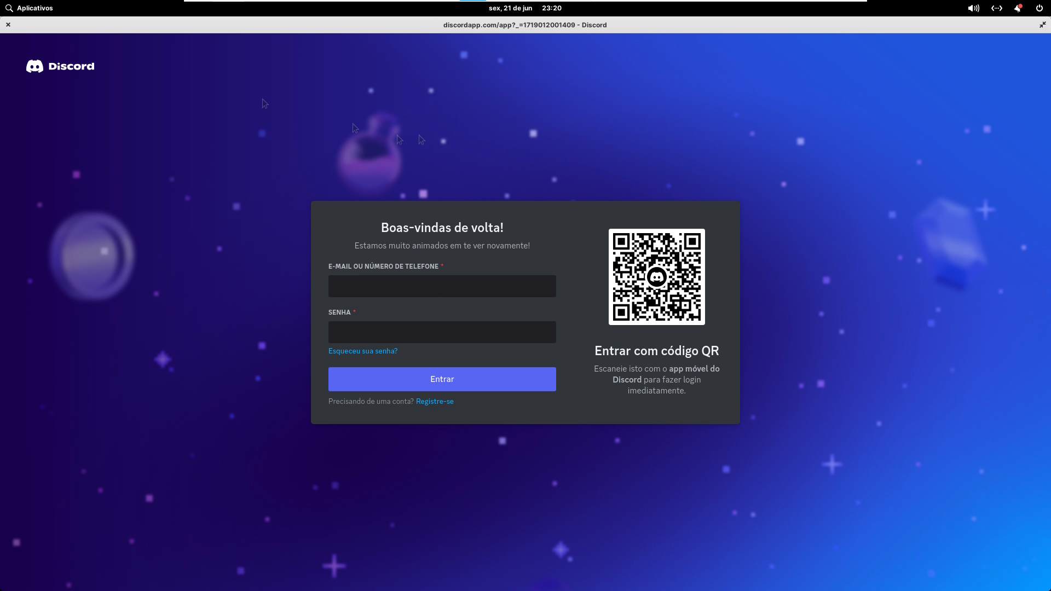*discord*

Comparativo entre os sistemas

Conclusões

Referências

https://www.youtube.com/watch?v=92NNyd3m79I

http://www.shawcomputing.net/resources/next/hardware/ns33_compatibility/nextstep_compatibility.html

https://www.nextcomputers.org/forums/index.php

https://tecnoblog.net/especiais/afinal-qual-a-relacao-do-macos-com-o-unix/

https://github.com/vcarosadev/VBoxVideo

https://www.youtube.com/watch?v=XAF0xdIiI20

https://hellosystem.github.io/docs/

https://www.youtube.com/watch?v=tuI2wX3ol2o

https://en.wikipedia.org/wiki/Elementary_OShttps://en.wikipedia.org/wiki/Elementary_OS

https://gs.statcounter.com/os-market-share

https://elementary.io/pt_BR/docs

https://www.youtube.com/watch?v=H-xc6c2ovMQ